ViTE

Business Analysis and Information Engineering INFO 6215



**Team Members:**

PM: Hemshree Mangrola

Chandrika Bolla

Malick Fairoz

Prasanna Kumar Hari

Ashwanth Ramji

Siddhyesh Warkhedkar

Table of Contents

1. BUSINESS CASE 3

1.1 Executive Summary: 3

1.1.1 Issue 3

1.1.2 Anticipated outcomes 3

1.1.3 Recommendations 3

1.1.4 Justification 4

1.2 Team Analysis 4

1.3 Problem Definition 5

1.3.1 Problem Statement 5

1.3.2 Organizational Impact 5

1.3.3 Technology 6

1.4 Project Overview 6

1.4.1 Project Description 6

1.4.2 Goals and Objectives: 7

1.4.3 Project Performance 7

1.4.4 Project Assumptions 8

1.4.5 Project Constraints 8

1.4.6 Major Project Milestones 8

1.7 Alternatives Analysis 11

2. REQUIREMENTS 12

2.1 Introduction 12

2.2 Business requirements 12

2.3 Functional Requirements 12

2.4 Non-Functional Requirements 13

2.5 User Requirements 14

3. DIAGRAMS AND PROCESS FLOW 15

3.1 Use Case Diagram 15

3.2 Activity Diagram 16

3.3 Process Flow Diagram 17

3.4 Class Diagram 18

3.5 WND Diagram 19

3.5.1 Sign up 19

3.5.2 Menu 19

3.6 User Personas 20

4. USE CASES 22

5. USER INTERFACE 24

5.1 Log in/ Sign in Screens 24

5.1.1 Welcome page 24

5.1.2 Sign Up Page 25

5.1.3 Log in Settings Page - 1 26

5.1.4 Log in Settings Page - 2 27

5.1.5 Account settings page 28

5.1.6 Change password page 29

5.2 Application browsing pages 30

5.2.1 Capture Image page 30

5.2.2 Captured Image Premium page 31

5.2.3 Premium results page - no ads 32

5.2.4 Basic results page - with ads 33

5.2.5 Store Results Map page 34

5.2.6 Favorite Store Results Map Page 35

5.2.7 Saved searches page 36

5.2.8 Recent Searches page 37

5.2.9 Notifications page 38

5.2.10 Basic users view of online stores page 39

5.2.11 Upgrade to premium page 40

5.2.12 Premium account info page 41

5.2.13 Account upgrade payment page 42

5.3 Vite App Policy Pages 43

5.3.1 Vite Ads policy page 43

5.3.2 Vite Terms of use page 44

5.3.2 Vite Privacy policy page 45

# 1. BUSINESS CASE

## 1.1 Executive Summary:

Vité is a mobile app platform that aims to become one hub for object scan-based market search. To be able to achieve this Vité wants to develop a mobile application that provides details of the object scanned and its availability in nearby local stores as well as online website.

The mobile application aims at aggregating the products of every category and brand possible. It will provide a streamlined and easy way of identifying not only the product but also its brand and the cost of the product in the nearby stores and online websites.

The business case will address the key business issues and gaps and benefits of this project, some recommendations along with detailed project objectives and assumptions.

### 1.1.1 Issue

People spend a lot of time looking for the exact product they see with someone or somewhere around them. The trouble of getting the right product with the best deal is another add on to the amount of precious time people spend. There are applications for one to check the prices online on all the websites but what about local stores? How if we can get a product at a cheaper price than the online sites. In fact, there is no dedicated application for one to recognize the exact product.

### 1.1.2 Anticipated outcomes

By developing a mobile application Vité aims at increasing its user base as people would find it convenient to look for the products and the prices rather than having to look into several websites and stores for the products and the prices.

It will also give local store owners a chance to flourish in the market.

### 1.1.3 Recommendations

* The mobile application will help expand the user base generating more revenue through premium features.
* This mobile application will be the first of its kind in the market and thus have the advantage of being first to market. This will enable them in capturing a greater percentage of the market base.
* The mobile application will provide all the product details and prices with links to the websites and local store addresses in a one place without having the user to navigate to multiple websites.
* It also gives a chance for the local business owners to flourish and reach out the targeted audience.

### 1.1.4 Justification

There is no such app which certainly provides such a streamlined and easy process of finding the product, its details and the cost on websites and local stores. This calls for a large user base of 200 million users who can use the app by being a primary or premium user. It also helps the local business and the online sites to standout in prices and the products they deliver in the market.

For an app like Vité, a key factor for success and for capturing a major chunk of the market is the ability to provide right product when the customer scans the product.

## 1.2 Team Analysis

|  |  |  |  |  |  |  |  |  |
| --- | --- | --- | --- | --- | --- | --- | --- | --- |
|  | **Role** |  |  | **Job Description** |  |  | **Name/Title** |  |
|  |  |  |  |  |  |
|  |  |  |  |  |  |  |  |  |
| Executive Sponsor | | |  | The Executive sponsor | |  | Mr. Herrington, Mr. Cuban, Mrs. Corcoran / Stakeholder | |
|  |  |  |  | provides executive support | |  |  |  |
|  |  |  |  | for the product and helps | |  |  |  |
|  |  |  |  | define the product vision | |  |  |  |
|  | | |  |  | |  |  | |
| Product Owner | | |  | The Product Owner works | |  | Product Manager | |
|  |  |  |  | with the team to define | |  |  |  |
|  |  |  |  | requirements, identify users, | |  |  |  |
|  |  |  |  | create user stories and do | |  |  |  |
|  |  |  |  | use case analysis | |  |  |  |
|  | | |  |  | |  |  | |
| Technology | | |  | This role provides all | |  | IT Administrator | |
| Support | | |  | technology support for the | |  |  |  |
|  |  |  |  | project | |  |  |  |
|  | | |  |  | |  |  | |
| Project Manager | | |  | Project Manager is the | |  | Hemshree Mangrola/Project Manager | |
|  |  |  |  | servant leader to the group. | |  |  |  |
|  |  |  |  | Tracks project progress and | |  |  |  |
|  | | |  |  |  |  |  | |
| Testing Support | | |  |  |  |  | Quality | |
|  |  |  |  |  |  |  | Assurance Lead | |
|  |  |  |  |  |  |  |  |  |

## 1.3 Problem Definition

### 1.3.1 Problem Statement

When we see a product, we spend a lot of time looking details like product brand, price, similar products and most importantly searching websites and stores for the best deal. Our app, Vité is focused on helping individual not only get the best deals from the web and stores near you but also recognizes the exact brand with details of the product when a user scans any product using their phone camera.

### 1.3.2 Organizational Impact

Launching a mobile application will have a significant impact on the company, the users and other key stakeholders. Following points describe the impact the project would have:

***Tools:*** Technology to suit a mobile phone certainly calls for a set of tools foranalysis, design, application development, regression testing and bug logging. Given that Vité is a start-up most tools being used will be open source tools.

The application in the end will have to be hosted on the App stores for both iOS and android.

A new set of integration platforms will also be required to provide app access to gallery and also to provide geographic location capabilities to users.

***Processes****:*The mobile application will provide easier and quicker access to the product details and the availability in the market. Signing up improves ease of access. The application also provides improved and increased functionality to premium users with no ads.

As far as the internal processes within the organization are concerned, a few additional authentication processes will be added, process for data encryption, security, neural network algorithm with Natural Language Processing and processes to support vendor inventory regularly will have to implemented.

***Hardware/Software:*** On an organizational level, a few new tools will have to be acquired.Since the team will be using most open source software free licenses will have to be generated will be required and a license for the mobile app development studio. New hardware will also have to be purchased to support the development activities. New end points on the cloud and additional server infrastructure may be required to support the additional traffic that the company expects. The users must download the mobile application from the app store.

***Roles and responsibility****:*The development of a mobile phone application, neural network algorithms and building relation with the vendors will require theroles of Software Engineers, Data Scientists, Data Engineer, Market Analyst. The team can have three interns for Data Scientist, Statistician and Data Analyst role.

### 1.3.3 Technology

The following is the overview of this mobile approach:

Phase 1: Gathering user requirements, business requirements, and business rules. Defining use cases, writing user personas defining the functionalities of the application. A business case will be formulated to implement Vité’.

Phase 2: The hardware and software tools required for app development will be purchased (quoting, negotiating contracts and purchasing). This phase will also involve Neural Network algorithm building, implementations and reworking on the accuracy of the algorithm. It will also involve building our local store network and tie-ups with the e-commerce sites.

Phase 3: This Phase involves the actual application development by the team. The different layers of the application will be developed and then integrated. This phase will also include testing (integration, functionality testing, usability testing). A beta version of the mobile application will be launched and tested with a selected user group and the mobile application will be upgraded accordingly.

Phase 4: The application will go live on the app store, this phase mainly involves the maintenance of the app, periodic upgrades and addition of further functionality to the application.

## 1.4 Project Overview

This section provides an overview of how the team plans to create a product that will address the problem faced currently and how the mobile phone application will cater to the needs of every individual. The overview consists of project description, goals and objectives for the project, project performance criteria, project assumptions, constraints and major milestones.

### 1.4.1 Project Description

75% of the user’s time is spent on researching the product on internet. Stats say, 71% of the people believe they get better deals online and 55% of these researches are made using a phone.

Isn’t that too much work and time for us?

We have decided to take advantage of the research time spent by people and the system of research used!

Vité is trying to delineate how we can save two most important things in today’s world, time and money. When we see a product, we spend a lot of time looking details like product brand, price, similar products and most importantly searching websites and stores for the best deal. Vité is focused on helping individual not only get the best deals from the web and stores near you but also recognises the exact brand with details of the product when one scans the product using their phone camera.

Vité is an application that uses deep learning image recognition to identify a particular product and find the same or similar product on multiple ecommerce websites. It shows the user the price comparison on different websites, so that you can choose the best one. Uses geo location to find the product in the nearest retail stores if you want the product immediately. If the same product is not found, it recommends a similar product based on what the product is, color, shape and brand.

Saves you energy, time and money.

### 1.4.2 Goals and Objectives:

|  |  |
| --- | --- |
| **Business goals/Objectives** | **Reasons** |
|  |  |
|  |  |
| 1.Creating an easy to access interface | To articulate the information in an orderly manner |
| for users | based on product scanned. Improving the ease of |
|  | access via the mobile application. |
|  |  |
| 2. Built a Neural Network engine with Natural Language processing | The product scanned by the user will be going through a neural network, identifying various identification points against the product details in our database |
|  |  |
|  |  |
|  |  |
| 3. Create a background for the vendors, especially the local owners for the scope of their business to grow | Provide the local business to flourish |

### 1.4.3 Project Performance

The following table lists the key resources, processes and services that is critical to perform the superiorities and prospective outcomes. These performance measures will be quantified and further defined in the detailed project plan:

|  |  |
| --- | --- |
| **Key resources/ Processes / Services** | **Performance Measure** |
|  |  |
|  |  |
| Ease of access | The Vité mobile app is expected to reduce |
|  | the overall time which a user spends looking for the product at the best price |
|  |  |
| Customization | User should be able to select whether they would like to look for the product in stores or online, at any geographic location |
|  |  |
| User interaction | User should be able to scan the product or the image of the product |
|  |  |
| Vendor Database | Vendors should be able to update their inventory of products along with the prices |
|  |  |
| 1.4.4 Project Assumptions |  |

* There is a need for the service in the market
* The existing customer base will quickly adapt to the new system
* The team will have sufficient training and skills to see the project to fruition
* The development team will be able to develop, test and debug the app and launch it within stipulated time
* There will be no attrition of users to other competitors while the mobile application is in the development phase
* The user stories gathered from the select set of users is representative of the interests of the entire population
* The local stores and the online websites are in agreement of the tie-up with Vité
* The local store vendors will update their inventory in the Vité database

### 1.4.5 Project Constraints

* The app will not allow users with the same email create multiple accounts
* The user data is not encrypted
* Presently the application is supported on a cloud which can handle only 10 million user end-points

### 1.4.6 Major Project Milestones

The project milestones have been identified as given in the table below. The target date for each project milestone is set after careful evaluation of the time and resources that will be utilized for the completion of every milestone. The targeted completion dates may change or will be adjusted as the project plan moves forward and will be finalized to establish a baseline project schedule.

|  |  |  |  |  |  |
| --- | --- | --- | --- | --- | --- |
|  | **Project Milestones** |  |  | **Target Date** |  |
|  |  |  |  |
|  |  |  |  |  |  |
| Project Charter | | |  | January 10th, 2018 | |
|  | | |  |  | |
| Project Planning (Budgeting, Scheduling, Resource | | |  | January 17th, 2018 | |
| Allocation) | | |  |  |  |
|  | | |  |  | |
| Project Plan Review & Completion | | |  | January 24th, 2018 | |
|  | | |  |  | |
| Project Execution | | |  | January 31st, 2018 | |
|  | | |  |  | |
| Phase 1 Completion (Requirements Gathering & Design) | | |  | February 15th, 2018 | |
|  | | |  |  | |
| Phase 2 Completion (Implementing & Testing) | | |  | March 25th, 2018 | |
|  | | |  |  | |
| Phase 3 Completion (Deployment & Maintenance) | | |  | March 30th, 2018 | |
|  | | |  |  | |
| Phase 4 | | |  | April 15th, 2018 | |
|  | | |  |  | |
| Project Closeout | | |  | April 20th, 2018 | |
|  |  |  |  |  |  |

1.5 Strategic Alignment

By supporting these strategic plans, this project will improve and enhance the user experience in a much efficient manner.

|  |  |  |
| --- | --- | --- |
| **Plan** | **Goals/Objective** | **Relationship to Project** |
|  |  |  |
| 2018 Strategic Plan for | Built an effective NN model | Development of a mobile phone |
| NN Development | And collect the product details | application will reduce the time |
|  | to support the building of | spent by users looking for their |
|  | Neural network model | desired products |
|  |  |  |
| 2018 Strategic Plan | Utilize modern technology to | Modern technology will help |
| Enhancement of User | provide a streamlined and | users ease the process of |
| Experience | easy to access app with | Looking for the product, be it |
|  | User required functionality | online or at a store nearby |
|  |  |  |
| 2018 Strategic Plan for | Provide local stores a chance | As an outcome of this project the |
| Local store | Of free advertisement and | company aims to collaborate |
| collaboration | A way to standout from others | with local store owners, after all |
|  |  | Who would not prefer a free ad |
|  |  | Leading to customers at door step |
|  |  |  |
| 2019 Strategic Plan for | Utilize browsing data and | This project would allow |
| Improving Profitability | promote related content and | Vité to utilize their existing |
|  | also do user subscriptions | business model and increase |
|  |  | their revenues. |
|  |  |  |

1.6 Cost Benefit Analysis

|  |  |  |  |
| --- | --- | --- | --- |
| **Action** | **Action Type** | **Description** | **First Year cost** |
| Get government permission and licenses | Cost | Initial investment of the project Vité | $70,000.00 |
| Cost of hardware and software | Cost | Cost of IT group to install new software’s and hardware systems including AWS | $200,000.00 |
| Hiring personnel | Cost | Hiring new staff with required skills and interest in the project (includes mainly interns and few full-time employees) | $500,000.00 |
| Earnings from Ad on the app | Savings | App will be supported by ad, providing revenue for primary user | $100,000.00 |
| Updating the system thus saving the manual work | Savings | Decrease employee counts by automating several modules | $150,000.00 |
| System maintenance will be reduced to every 5-6 months instead of monthly updates | Savings | Making the system more efficient thus needing lesser maintenance will lead to less frequent calls to IT services | $ 70,000.00 |
| Premium user subscription amount (anticipating 60,000 premium users over the year) | Savings | The premium user will be paying $12 for subscription annually | $ 720,000.00 |
| **Net first year savings** |  |  | **$ 270,000.00** |

## 1.7 Alternatives Analysis

|  |  |
| --- | --- |
| **Factors for Alternate analysis** | **Reason for not selecting the alternate analysis** |
| Keep the current on-ground system of human predictions in place | Unnecessary time utilized by the user for looking for the right product  Lack of automation  Time utilization while looking for better deals |
| Outsource the implementation of the neural network algorithm | Significant higher cost  Expertise at home will be wasted  Vendor’s lack of familiarity with the entire concept and the products |

# 2. REQUIREMENTS

## 2.1 Introduction

The section documents all the business requirements, the user requirements and functional requirements. This document will be used to code functionality into the product

## 2.2 Business requirements

A business requirements document (BRD) details the business solution for a project including the documentation of customer needs and expectations. If an initiative intends to modify existing (or introduce new) hardware/software, a new BRD should be created. Business requirements are specifications when completed and delivered, provide value to the product.

|  |  |
| --- | --- |
| **ID** | **Business Requirement** |
| B1 | The app should allow all users to scan/search/save products |
| B2 | The app should allow users to switch between local and online stores |
| B3 | The app should allow users to upgrade to premium accounts |
| B4 | The app should allow users to favorite their search results |
| B5 | The app should allow user to change preferences |

## 2.3 Functional Requirements

|  |  |
| --- | --- |
| **ID** | **Business, User and Functional Requirements** |
| B1 | The app should all users to scan/search/save products |
| User Role | Premium Users |
| Goal U1 | Scan Products |
| U1.1 | Premium Users should be able see products on local and online products |
| U1.1F1 | The app should use 3D Neural network scanning when Premium users scan |
| U1.1F | The app should allow users to save products searches |
| U1.1F3 | The app should allow users to share their product searches |
| User Role | Primary users |
| Goal U1 | Scan Products |
| U1.1 | Primary users should be able to see products available in local stores |
| U1.1F1 | The app should use 2D Neural network scanning when Primary users scan |
| U1.1F2 | The app should not allow users to save product searches |
| U1.1F3 | The app should not allow users to share their product searches |
| B2 | The app should allow premium users to switch between local and online stores |
| User Role | Premium Users |
| Goal U1 | Switch between local and online stores |
| U1.1 | Premium users should be able to switch between local and online stores |
| U1.1F1 | The app should allow users to switch between local and online store search results |
| U1.1F2 | The app should allow users to visit online stores using hyperlinks |
| U1.1F3 | The app should allow users to contact local stores by clicking information on app |
| User Role | Primary Users |
| Goal U1 | Switch between local and online stores |
| U1.1 | Primary users should not be able to view online stores results |
| U1.1F1 | The app should prompt users to upgrade to premium subscription |
| U1.1F2 | The app should only show local stores results |
| B3 | The app should allow Primary users to upgrade to premium accounts |
| User Role | Premium Users |
| Goal U1 | Upgrade to premium accounts |
| U1.1 | Premium users to have all benefits of premium accounts at all times |
| User Role | Primary Users |
| Goal U1 | Upgrade to premium accounts |
| U1.1 | Primary users should be able to upgrade to premium accounts |
| U1.1F1 | The app should allow users to upgrade to premium accounts |
| U1.1F2 | The app should communicate with app store to authenticate payments |
| U1.1F3 | The app should upgrade Primary account on successful payment receipts |
| B4 | The app should allow users to favorite their search results |
| User Role | Premium Users |
| Goal U1 | Favorite search results for all products |
| U1.1 | Premium users should be able to favorite their search results |
| U1.1F1 | The app should allow users to save search results for favorite products |
| U1.1F2 | The app should allow users to revisit and view saved search results |
| U1.1F3 | The app should allow users to make changes to saved search results |
| User Role | Primary Users |
| Goal U1 | Favorite search results for all products |
| U1.1 | Primary users should not be able to favorite their search results |
| U1.1F1 | The app should not allow users to save search results for favorite products |
| B5 | The app should allow users to change app preferences |
| User Role | Premium Users |
| Goal U1 | Preferences |
| U1.1 | Premium Users should be able to change app preferences |
| U1.1F1 | The app should allow users to change notification preferences |
| U1.1F2 | The app should allow users to disable ads |
| U1.1F3 | The app should allow users to set up store preferences |
| U1.1F4 | The app should allow users to check status of their premium account |
| User Role | Primary Users |
| Goal U1 | Primary Users should have limited access to change app preferences |
| U1.1 | Premium Users should be able to change app preferences |
| U1.1F1 | The app should allow users to change notification preferences |
| U1.1F2 | The app should not allow users to disable ads |
| U1.1F3 | The app should not allow users to set up store preferences |
| U1.1F4 | The app should not allow users to check status of their premium account |

## 2.4 Non-Functional Requirements

|  |  |
| --- | --- |
| **ID** | **Non-Functional Requirements** |
| Operational Requirements | |
| Security | |
| N-SEC1 | Information of all users is protected |
| N-SEC2 | Limited access to Primary Users |
| N-SEC3 | Data transmitted between databases and app should be encrypted |
| N-SEC4 | Log in access limited to authorized users |
| Availability | |
| N-AVAIL1 | The system should be available 24*7 throughout the year |
| N-AVAIL2 | Support for discrepancies in information should be provided |
| Efficiency | |
| N-EFF1 | The app should be able to collect and send bug reports |
| N-EFF2 | The app should be able handle traffic effectively |
| N-EFF3 | The app should be able identify between user profiles |
| N-EFF4 | The 3D and 2D Neural engines should function with 100% efficiency |
| Integrity | |
| N-INT1 | The information on product should match with local and online stores |
| N-INT2 | The information needs to be updated on a real-time basis |
| Usability | |
| N-UAT1 | The app should be user friendly for all user |
| N-UAT2 | The system should be easy to navigate for all access holders |
| N-UAT3 | The system and app should be very responsive |
| Survivability | |
| N-SRV1 | System should have full-proof security to prevent external breaches |
| N-SRV2 | System should have back up measures in place for emergencies |
| Reliability | |
| N-REL1 | The mobile application should have a glitch-free performance |
| N-REL2 | The system should upgrade accounts without issues |
| N-REL3 | The app should access and give appropriate results for both 3D and 2D neural search |
| Revision Requirements | |
| Maintainability | |
| N-MNT1 | The database data should be easy to update and refresh |
| N-MNT2 | Bugs on app should be concise and reported immediately |
| Scalability | |
| N-SCA1 | System should be able to support future requests for expansion |
| N-SCA2 | Integration with multiple social media platforms should be possible |
| Verifiability | |
| N-VER1 | Password reset for premium users should be allowed once user identified |
| Flexibility | |
| N-FLEX1 | The app should be able to adapt for different screen sizes of mobile applications |
| Transition Requirements | |
| Interoperability | |
| N-INTO1 | The system should be able to function all different available mobile OS’ |
| Portability | |
| N-POR1 | System should be able to read data and transport from databases to user app |
| Reusability | |
| N-RES1 | Functions and subroutines defined for one part of the code should be reusable when called from other sections of code |

## 2.5 User Requirements

|  |  |
| --- | --- |
| **ID** | **User Requirements** |
| U1 | Should be able to make purchase decisions after scanning product & viewing results |
| U2 | Should be able to contact stores regarding inventory using app from anywhere |
| U3 | Should be able to easily navigate through mobile app UI |
| U4 | Should be able to upgrade to premium account at convenience |

# 3. DIAGRAMS AND PROCESS FLOW

## 3.1 Use Case Diagram

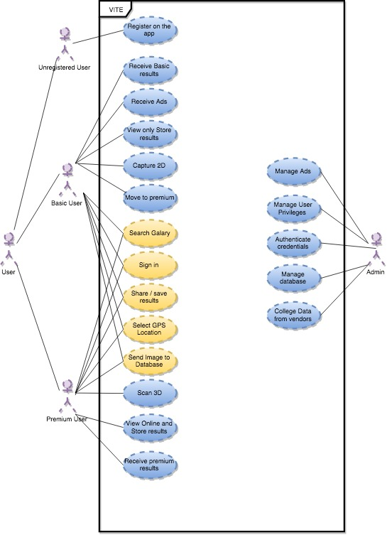

## 3.2 Activity Diagram

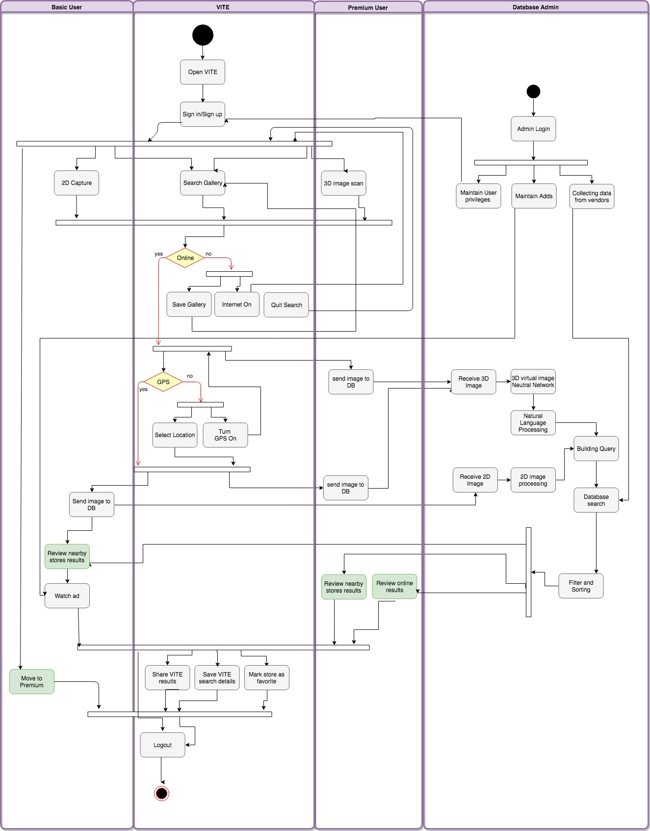

## 3.3 Process Flow Diagram

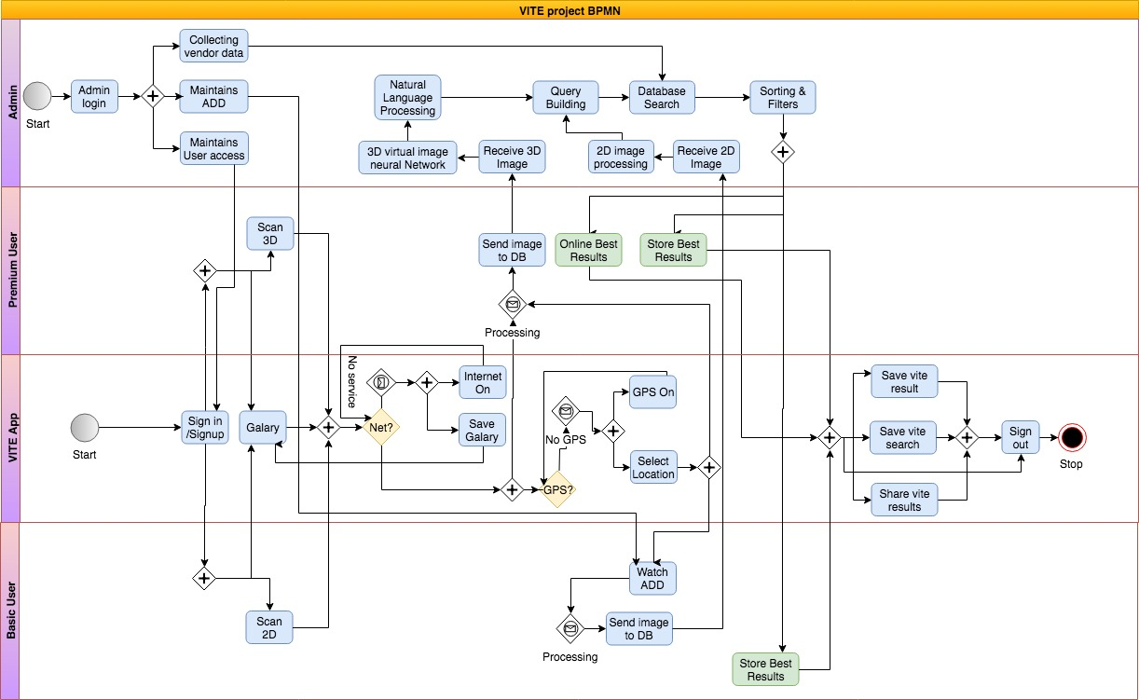

## 3.4 Class Diagram

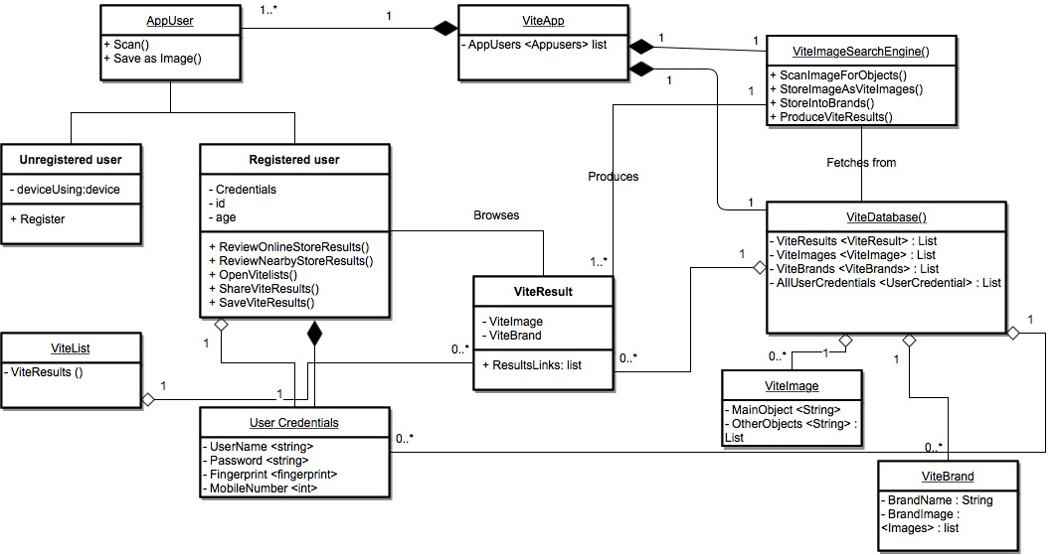

## 3.5 WND Diagram

### 3.5.1 Sign up

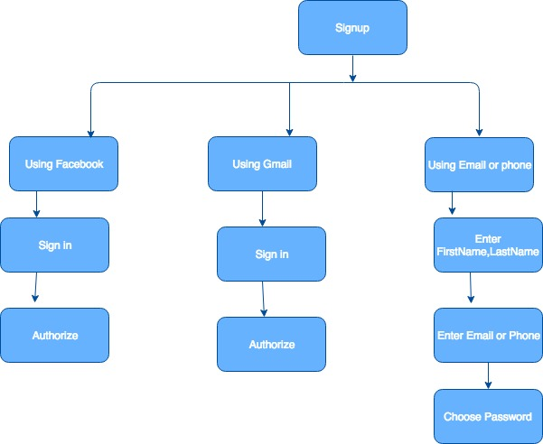

### 3.5.2 Menu

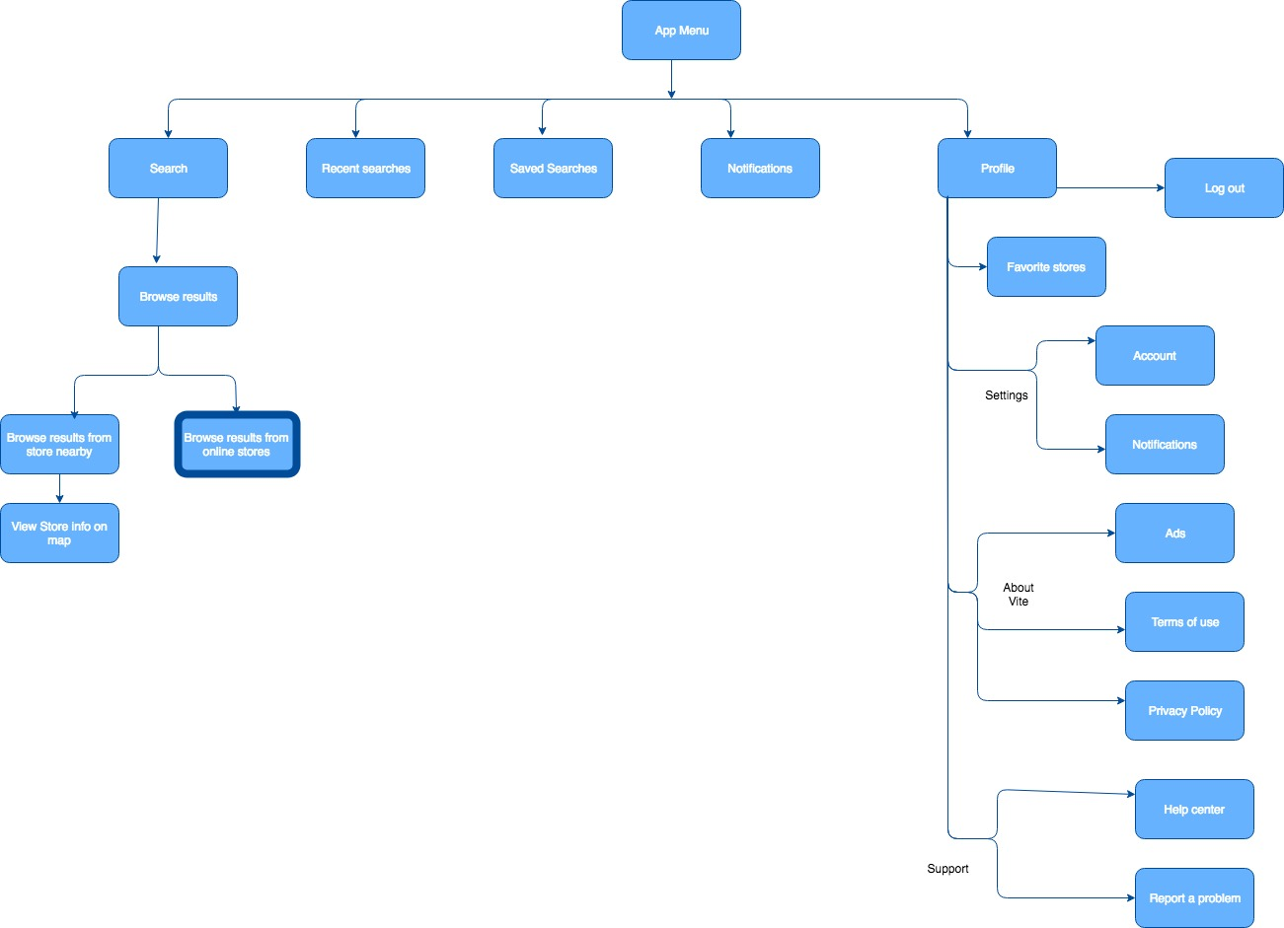

## 3.6 User Personas

A person looking at the camera

Description generated with very high confidence

**John Smith**

“I need to quickly find a store nearby that sells a product that I need for next day’s event.”

John finds it difficult to arrange events in his organization as they are often scheduled a day before and he is not able to find stores nearby that sell the products he wants.

Age: 22 years

Occupation: Event coordinator at EventsCosta

Income: $70000/year

Mobile Phone using: iphone 6s

Technical Profile: Comfortable using iphone and macOS systems

A person wearing a white shirt

Description generated with very high confidence

“I want to search for that product at a store near me that sells that product my friend uses by taking a picture or save picture and search for it later”

**Monica Geller**

Monica often finds some products of her Chinese friends very interesting and she forgets the name of the products after a few days she meets them.

Age: 32 years

Occupation: Chef at NewYork Corner Restaurant

Income: $80000/year

Mobile Phone using: iphone 6s

Technical Profile: Comfortable using iphone, ipad and Windows systems

A person posing for a picture

Description generated with very high confidence

“I wish I have an app that finds the best deals for me out of all the websites. For my emergency needs, it would be better if I can find those products at stores near me.”

**Katie Otto**

Age: 40 years

Occupation: Housewife with 3 children

Income: $20,000/year

Mobile Phone using: iPhone 6

Technical profile: Familiar with MacOS systems and iPhone

Looking after her triplets, Katie does not get enough time to browse online to find the best deal out of all the e-commerce websites available.

# 4. USE CASES

|  |  |
| --- | --- |
| **ID:** | UC-1 |
| **Title:** | User Registration Perspective |
| **Description:** | User accesses the downloaded application and provides credentials like username and password |
| **Primary Actor:** | Application User |
| **Preconditions:** | User has application on his mobile phone |
| **Postconditions:** | User is registered and gets an email notification after successful registration |
| **Main  Success Scenario:** | 1. User selects to register into the application 2. System displays a form for registration 3. User selects to input fingerprint if he/she opts to 4. User clicks submit button 5. System registers the user into the application database |
| **Extensions:** | Registration error  1.When the user submits invalid or incorrect credentials required  2.When the registered user tries to re-register |
| **Frequency of Use:** | When the user wants to register for the first time |
| **Status:** | Design elements under review |
| **Owner:** | Chandrika Bolla |
| **Priority:** | Medium |

|  |  |
| --- | --- |
| **ID:** | UC-2 |
| **Title:** | User Login Perspective |
| **Description:** | User accesses the downloaded application and provides credentials like username and password and/or fingerprint for login |
| **Primary Actor:** | Registered User |
| **Preconditions:** | User has application on his mobile phone and has registered with the application |
| **Postconditions:** | User logs in and can access his saved products |
| **Main  Success Scenario:** | 1. User selects to login into the application 2. System displays a form to login 3. User selects to input fingerprint if he/she opts to 4. User clicks submit button 5. System checks the user with the database and validates |
| **Extensions:** | Error:  When the user types in wrong login credentials |
| **Frequency of Use:** | Once every time registered user accesses and wants to search database or access Vite list |
| **Status:** | Design elements under review |
| **Owner:** | Chandrika Bolla |
| **Priority:** | Medium |

|  |  |
| --- | --- |
| **ID:** | UC-3 |
| **Title:** | Search Perspective |
| **Description:** | User accesses the downloaded application and scans a product to search in the database for the same or similar products. |
| **Primary Actor:** | Application User |
| **Preconditions:** | User has logged in into the application |
| **Postconditions:** | User finds same or similar products in multiple online or local retail stores |
| **Main  Success Scenario:** | 1. User scans a product 2. Scanned product is cross verified with the database 3. Product relevant matches are displayed to the user 4. User can save product in Vite List |
| **Extensions:** | Scan Error  When user does not scan the product properly |
| **Frequency of Use:** | Multiple times based on user’s search criteria |
| **Status:** | Design elements under review |
| **Owner:** | Chandrika Bolla |
| **Priority:** | Medium |

# 5. USER INTERFACE

## 5.1 Log in/ Sign in Screens

### 5.1.1 Welcome page

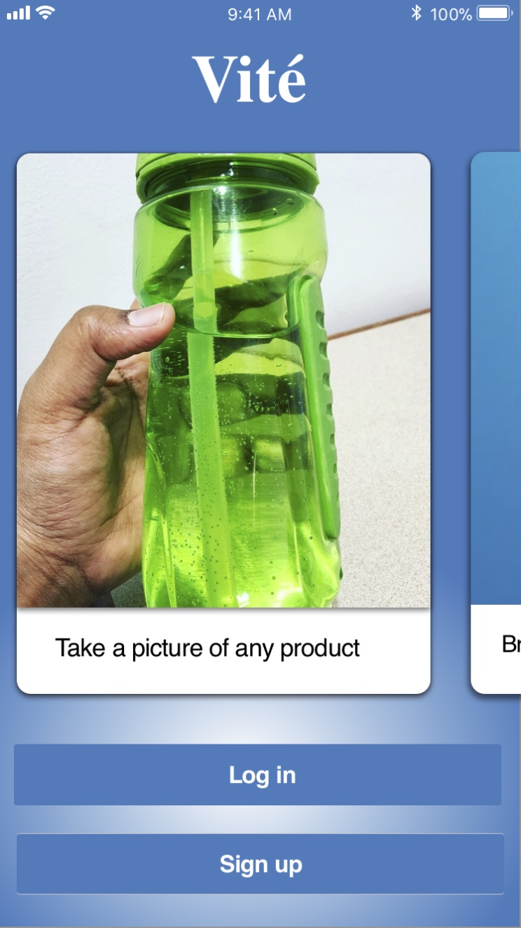

### 5.1.2 Sign Up Page

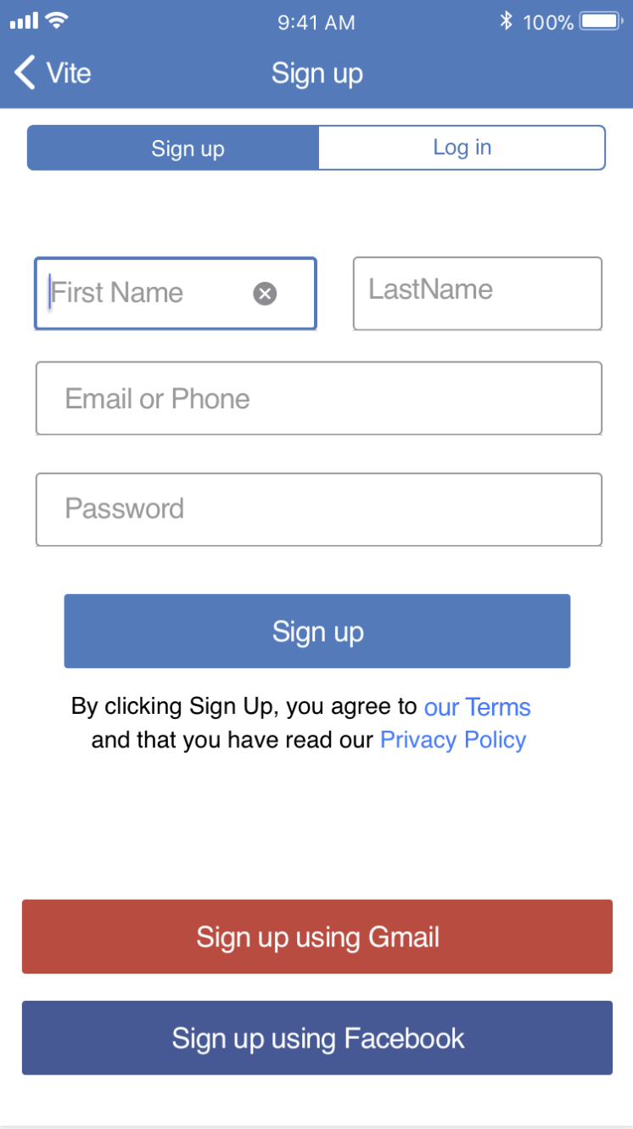

### 5.1.3 Log in Settings Page - 1

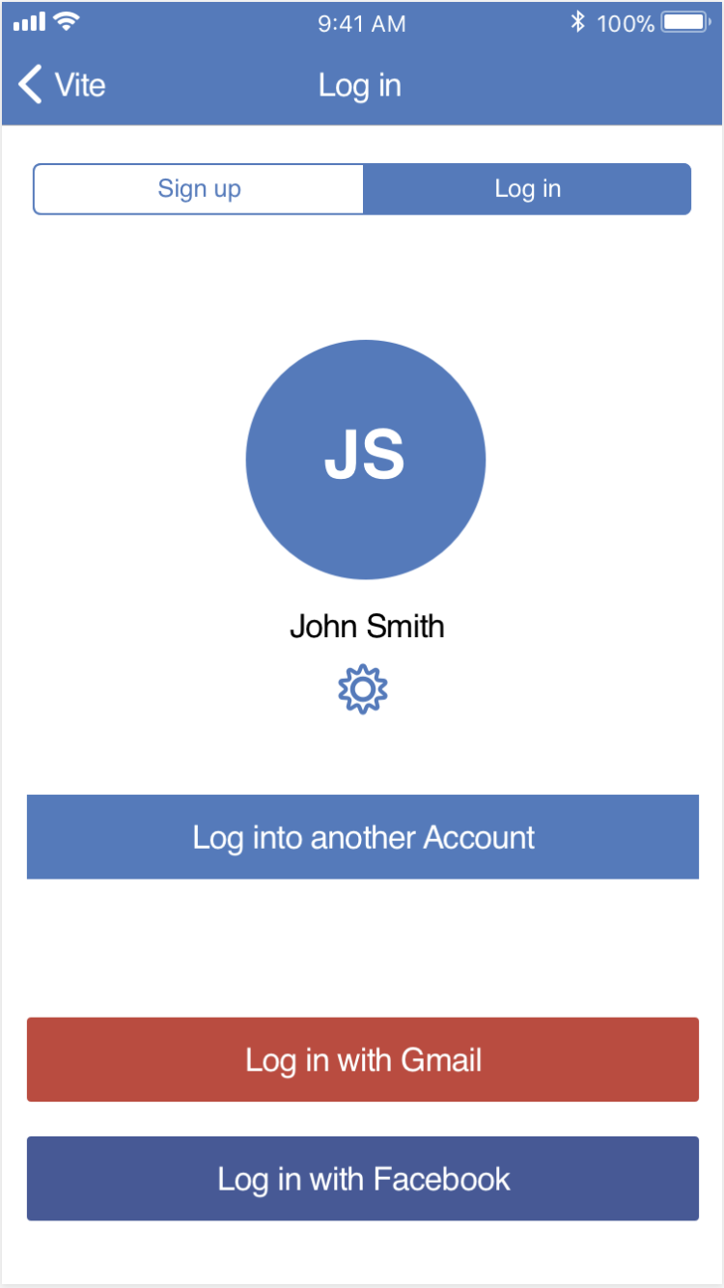

### 5.1.4 Log in Settings Page - 2

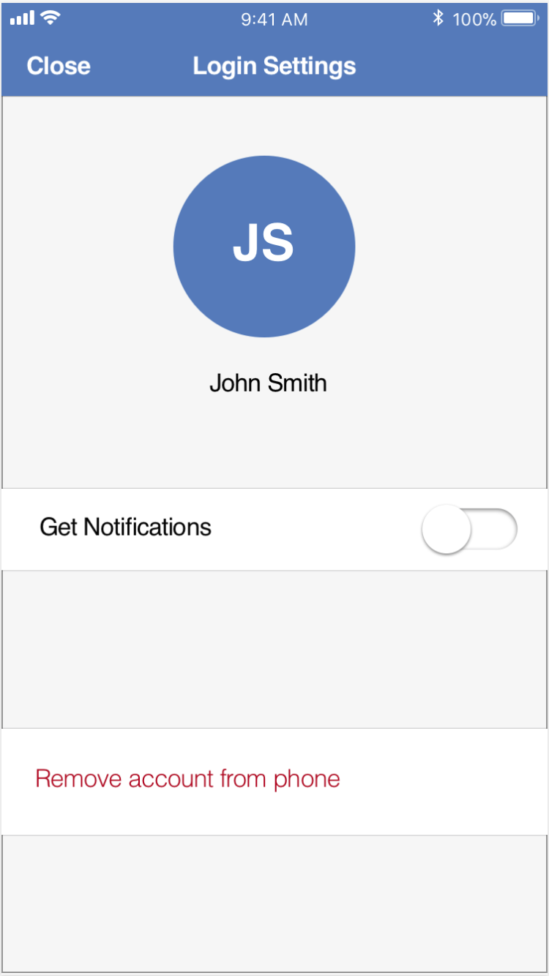

### 5.1.5 Account settings page

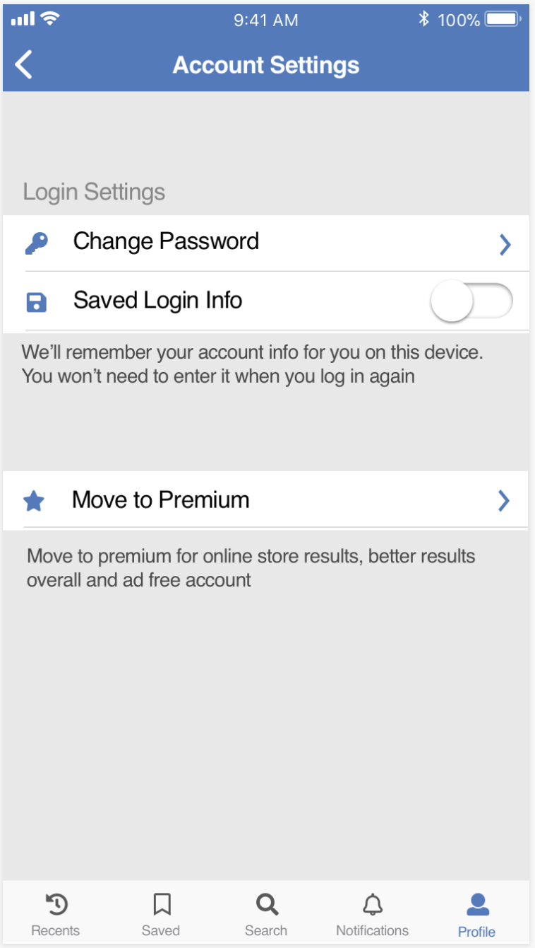

### 5.1.6 Change password page

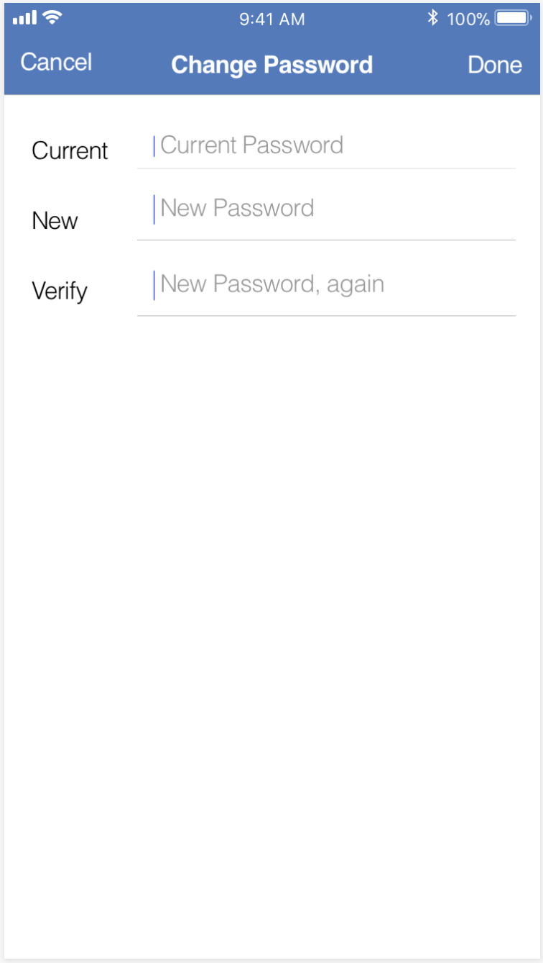

## 5.2 Application browsing pages

### 5.2.1 Capture Image page

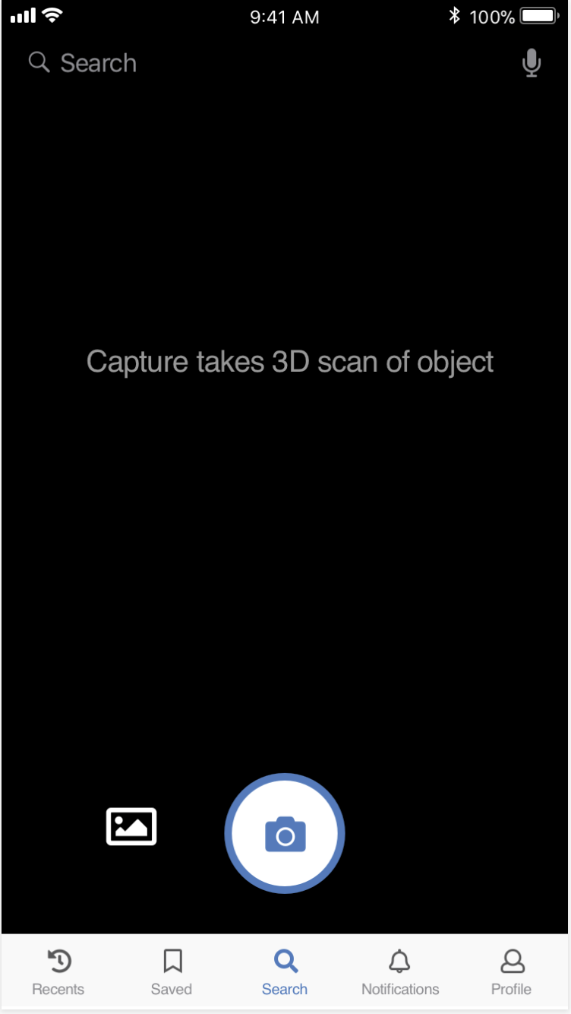

### 5.2.2 Captured Image Premium page



### 5.2.3 Premium results page - no ads

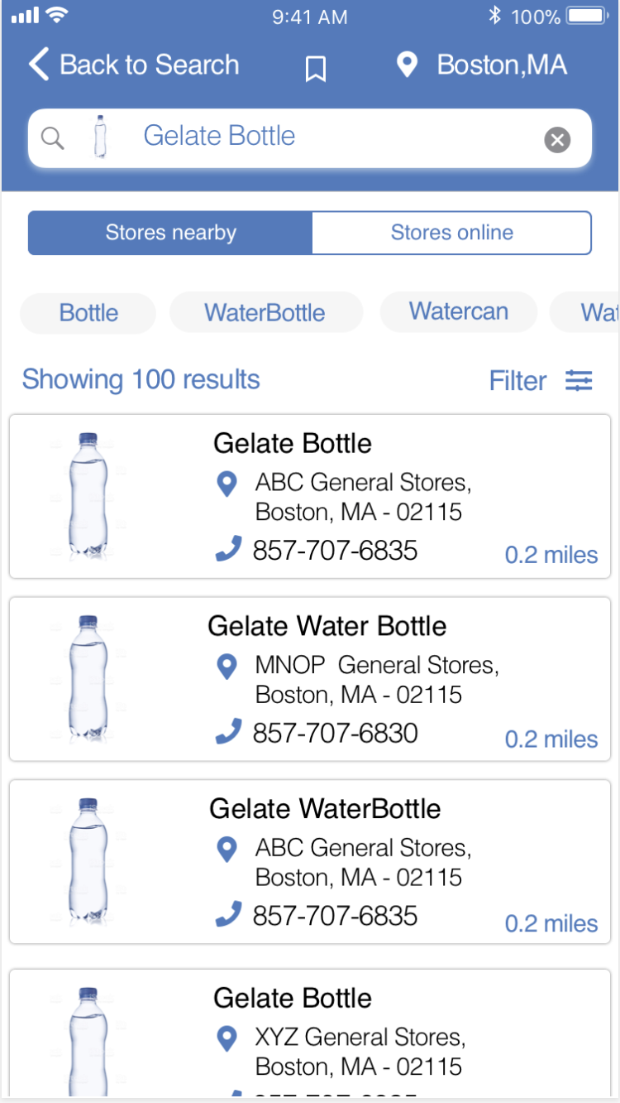

### 5.2.4 Basic results page - with ads

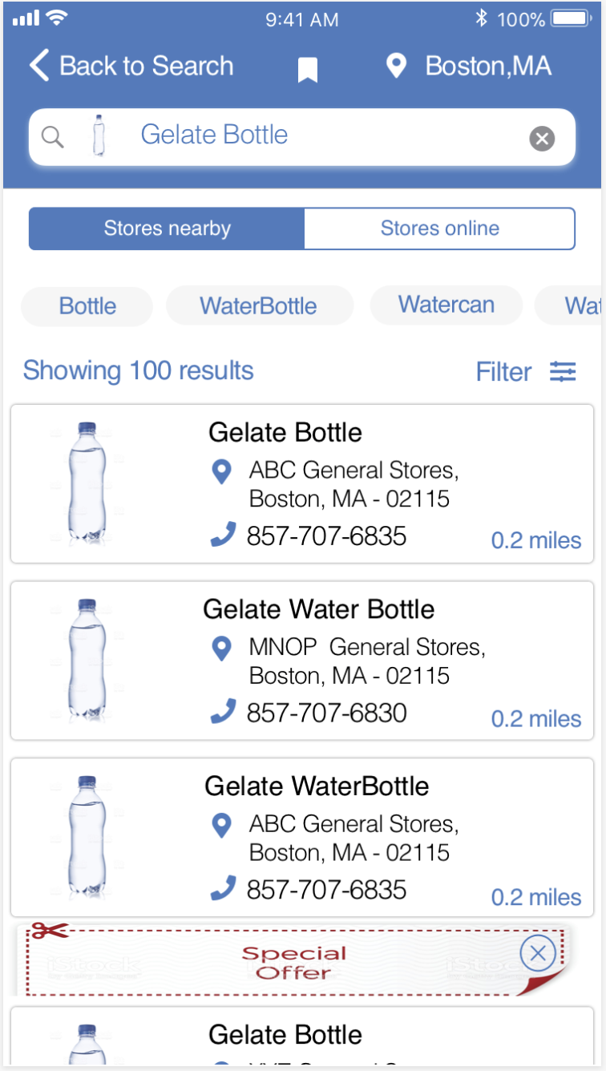

### 5.2.5 Store Results Map page

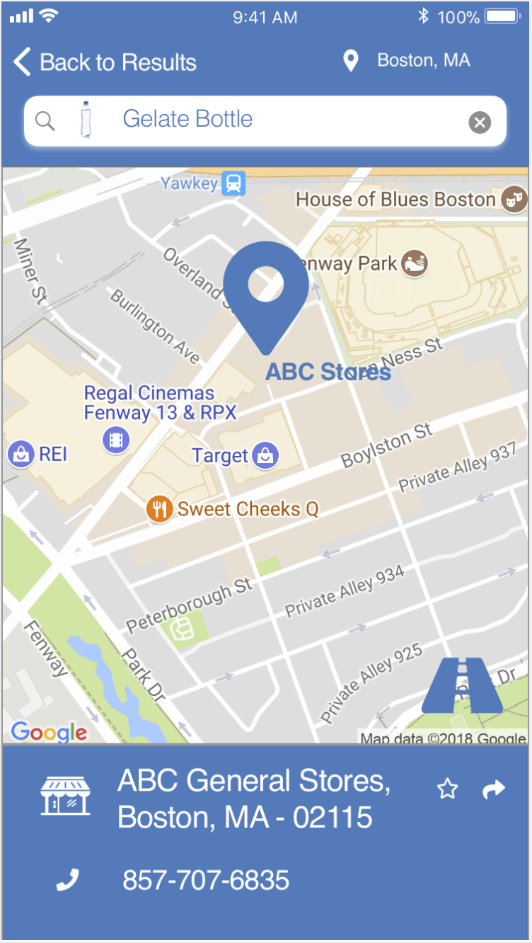

### 5.2.6 Favorite Store Results Map Page

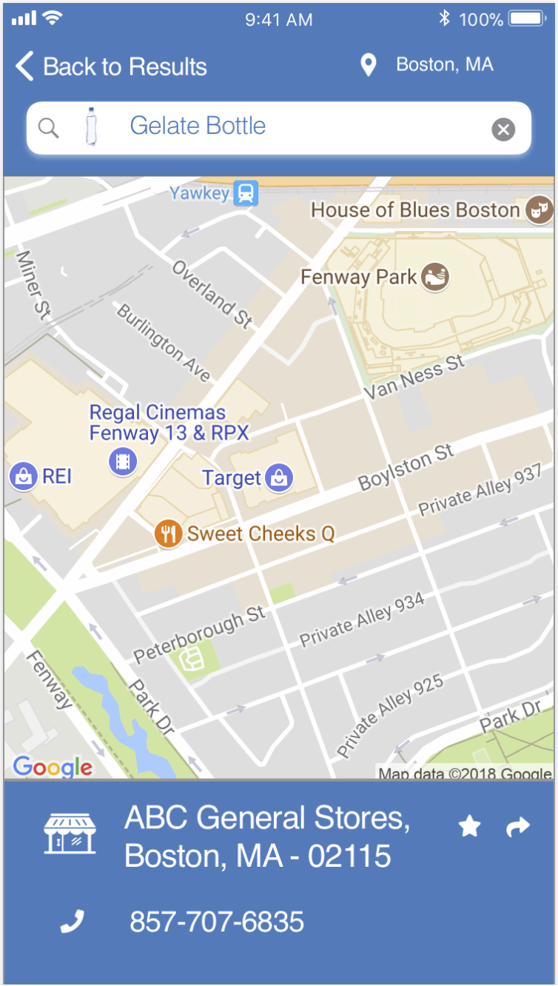

### 5.2.7 Saved searches page

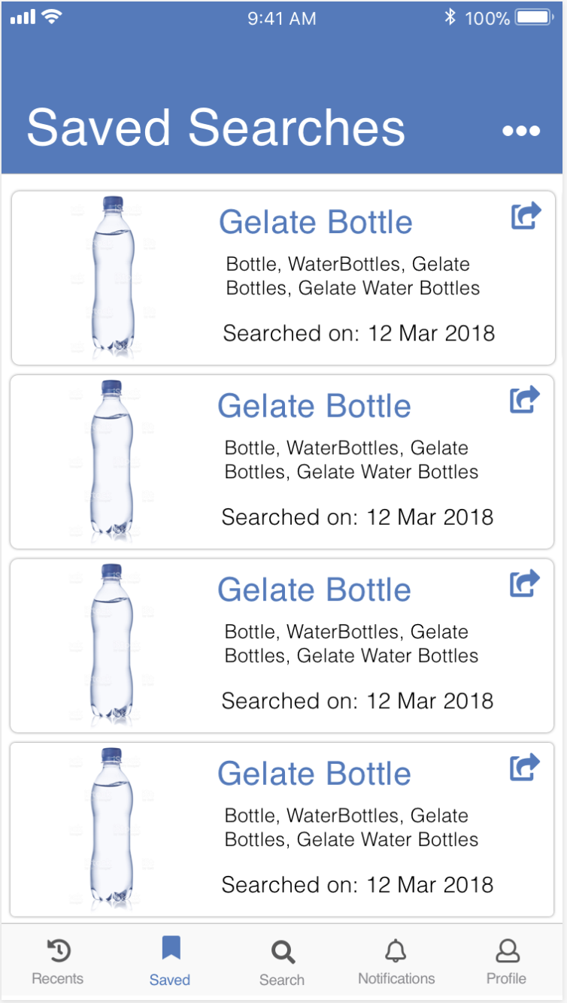

### 5.2.8 Recent Searches page

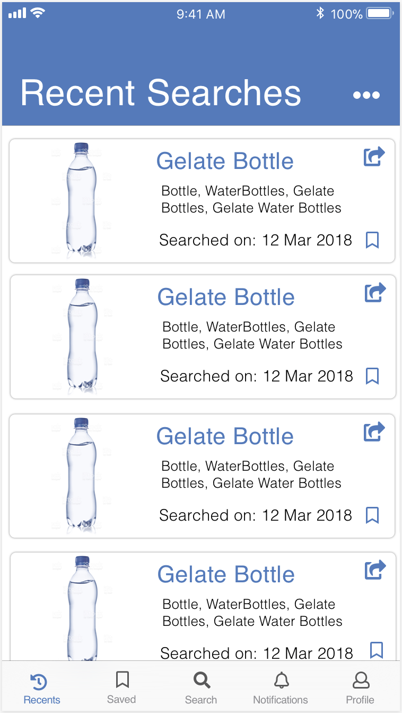

### 5.2.9 Notifications page

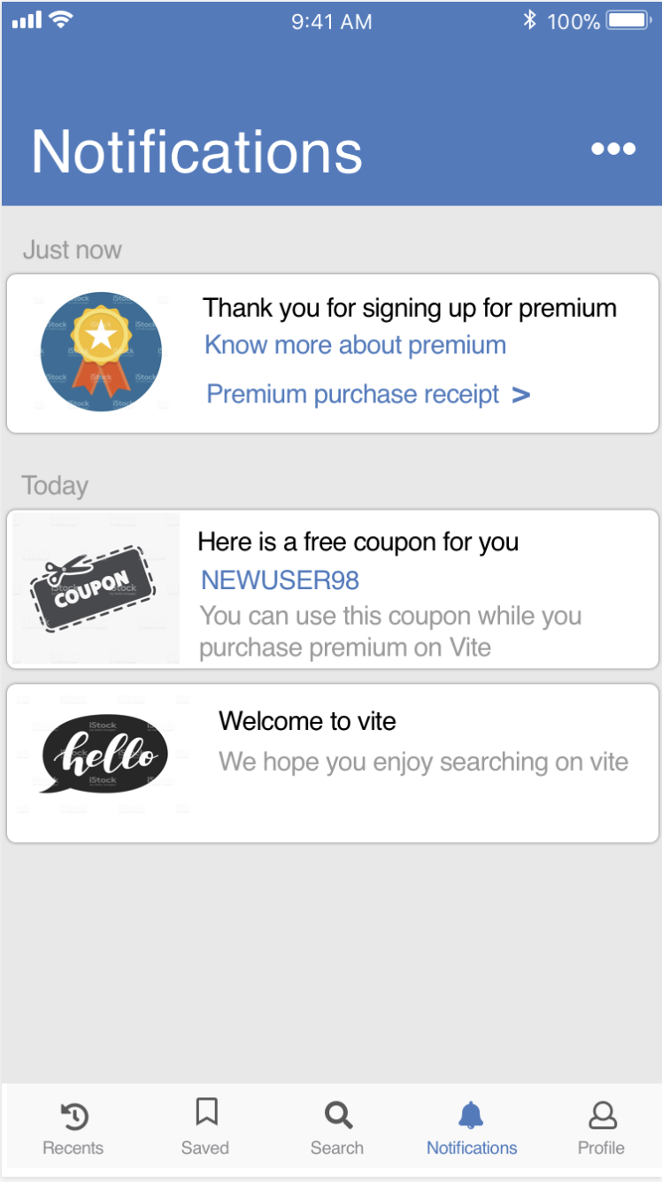

### 5.2.10 Basic users view of online stores page



### 5.2.11 Upgrade to premium page

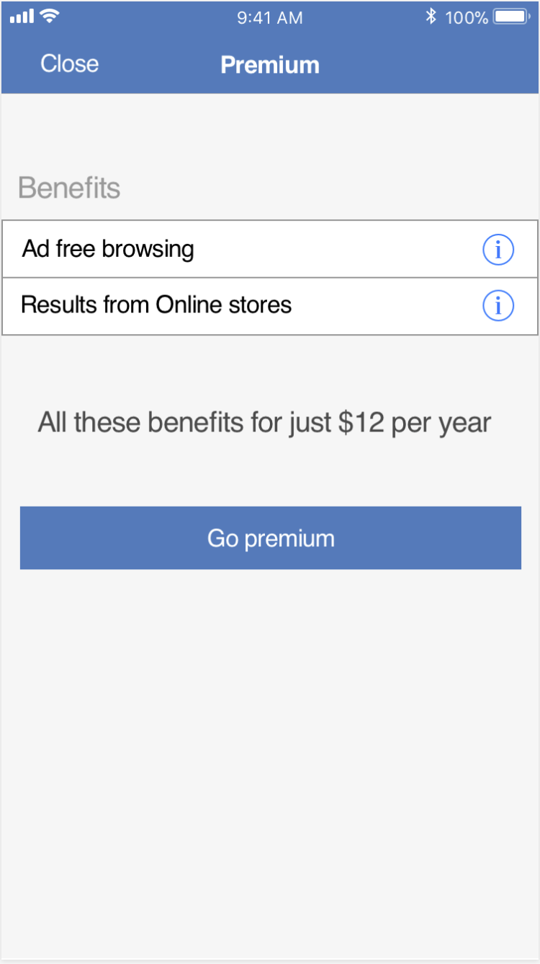

### 5.2.12 Premium account info page

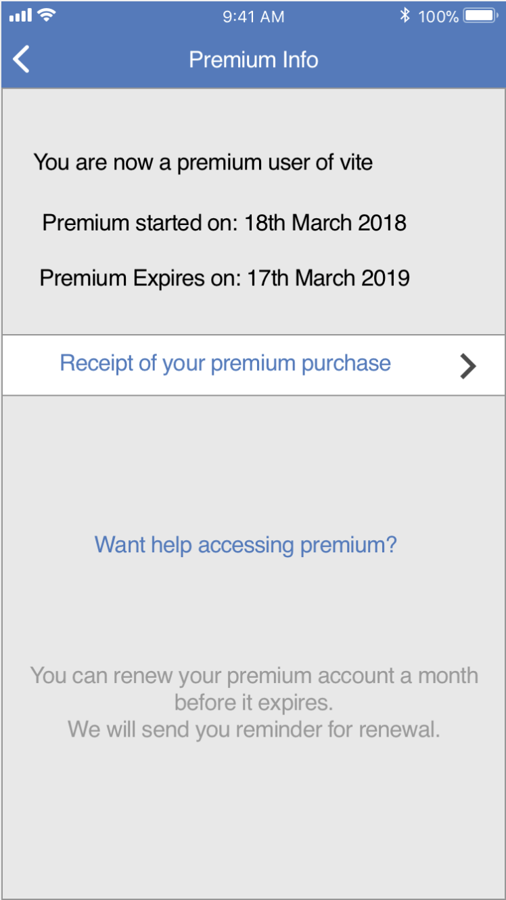

### 5.2.13 Account upgrade payment page

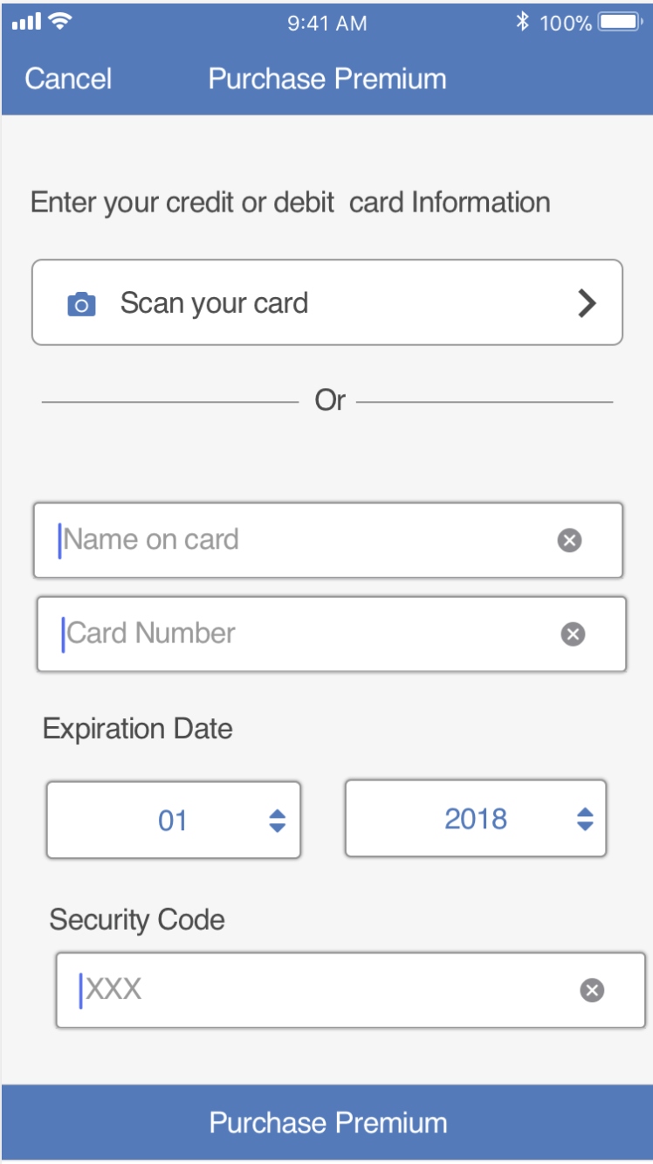

## 5.3 Vite App Policy Pages

### 5.3.1 Vite Ads policy page



### 5.3.2 Vite Terms of use page

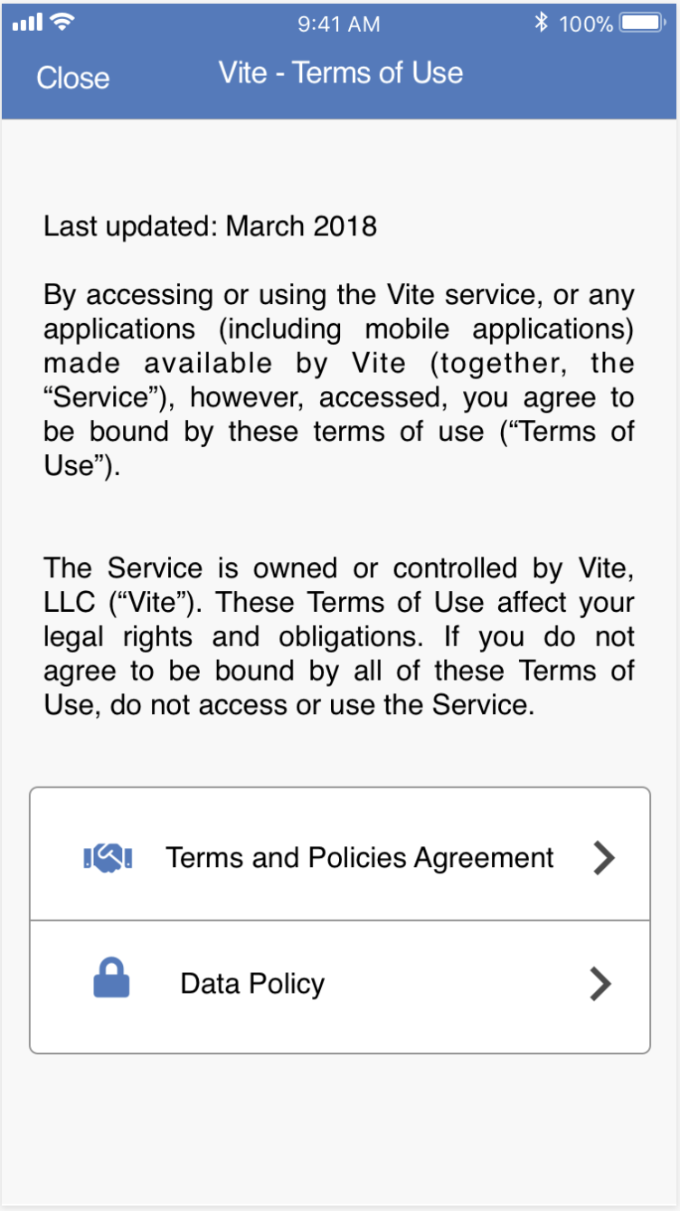

### 5.3.2 Vite Privacy policy page

